

**OUTREACH SCHOOLS EXAMINATIONS BOARD**

**BEGINNING OF TERM III EXAMINATION 2024**

**P.4 INTEGRATED SCIENCE**

***Time Allowed: 2hours 15 Minutes***

**Pupil’s Name: …………………………………………..……………………**

**Class: …………………………………….………………………………………**

**School Name: ………………………………………………………………….**

|  |  |  |
| --- | --- | --- |
| **FOR EXAMINERS’**  USE ONLY | | |
| **Qn. No.** | **MARKS** | **EXR’S**  **No.** |
| **1 - 10** |  |  |
| **11 – 20** |  |  |
| **21 – 30** |  |  |
| **31 – 40** |  |  |
| **41 – 43** |  |  |
| **44 – 46** |  |  |
| **47 – 49** |  |  |
| **50 - 52** |  |  |
| **53 - 55** |  |  |
| **TOTAL** |  |  |

**Read the following instructions carefully:**

1. This paper has two sections: **A** and **B**
2. Section **A** has 40 questions (40 marks)
3. Section **B** has 15 questions (50 marks)
4. Answer all questions. All the working for both sections A and B must be shown in the spaces provided.
5. All working must be done using a blue or black ball point pen or ink. Any work done in pencil will NOT be marked except drawings and diagram.
6. Unnecessary changes in your work and handwriting that cannot be easily read may lead to loss of marks.
7. Do not fill anything in the table indicated

**“For examiners’ use only”** and the boxes inside the question paper.

***Turn Over***

**SECTION A**

1. Name one example of a living thing.

_______________________________________________________________________

1. What are **flowering plants**?

_______________________________________________________________________

1. Give one example of a bad eating habit.

_______________________________________________________________________

1. Mention one solute used in the making of O.R.S?

_______________________________________________________________________

1. What name is given to a young plant?

_______________________________________________________________________

1. Name the instrument used by doctors to see germs.

_______________________________________________________________________

1. Name the garden tool below.

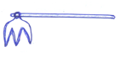

_____________________________________________________

1. Name the best season for harvesting crops.

_______________________________________________________________________

1. Which soil has the smallest and finest particles?

_______________________________________________________________________

1. How do fish move?

____________________________________________________________________

1. Write down one local method of preserving food.

_______________________________________________________________________

1. Name one set of teeth.

_______________________________________________________________________

1. 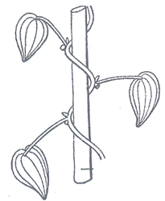Name the method used by weak stemmed plants to climb others as below

______________________________________________________________

1. How are cats useful at home?

_______________________________________________________________________

1. Which sense organ is used to detect sound?

_______________________________________________________________________

1. Give one agent of pollination.

_______________________________________________________________________

1. Which type of soil is used by farmers for pottery?

_______________________________________________________________________

1. Name the part of the plant that absorbs water and mineral salts from the soil.

_______________________________________________________________________

1. State one type of family.

_______________________________________________________________________

1. How are root nodules important to leguminous plants?

_______________________________________________________________________

1. Give one way of making water safe for drinking.

_______________________________________________________________________

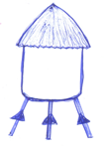**The diagram below shows a food ban. Use it to answer questions 22-24.**

22. Name the food ban shown.

___________________________________________________

1. Mention one example of crops commonly stored in the food ban shown.

**W**

___________________________________________________

1. Name the part marked **W** in the diagram.

_______________________________________________________________________

1. Mention one cause of dehydration.

_______________________________________________________________________

1. Explain germination.

_______________________________________________________________________

1. Give one way of controlling soil erosion in the garden.

_______________________________________________________________________

1. Apart from breathing, give one other use of leaves to plants.

_______________________________________________________________________

1. How is a female anopheles mosquito harmful to people?

_______________________________________________________________________

1. Mention the class of food that helps in body growth.

_______________________________________________________________________

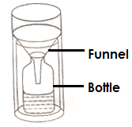**The diagram below is of a weather instrument. Use it to answer questions 31.**

1. Name the instrument drawn.

________________________________________________

1. How is wind useful to people?

_______________________________________________________________________

1. Give one reason why people plant trees near their homes.

_______________________________________________________________________

1. Mention one way through which worms eater our bodies.

_______________________________________________________________________

1. Give one way of promoting personal hygiene.

_______________________________________________________________________

1. State any one diarrheal disease.

_______________________________________________________________________

1. Mention one importance of flowers to people.

_______________________________________________________________________

1. What are weeds?

_______________________________________________________________________

1. Which groups of living things make their own food?

_______________________________________________________________________

1. Give one reason for giving First Aid.

_______________________________________________________________________

**SECTION B**

1. a)What are germs?

_______________________________________________________________________

b) List down any two types of germs.

i) _____________________________________________________________________

ii) _____________________________________________________________________

c) Give any one disease vector.

_______________________________________________________________________

1. a) Define weather.

_______________________________________________________________________

b) State one condition of weather.

_______________________________________________________________________

c) List any two elements of weather.

i) _____________________________________________________________________

ii) _____________________________________________________________________

1. a) Which term is used to mean the vertical arrangement of soil layer?

_______________________________________________________________________

1. Mention two components of soil.

i)__________________________________ (ii) ________________________________

c) Why is loam soil good for growing crops?

_______________________________________________________________________

**The diagram below shows a part of a flower. Use it to answer questions that follow.**

1. 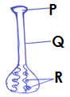a) Name the part of the flower shown

___________________________________________________

b) Name the parts marked **P** and **Q**

i) **P**_______________________________________________

ii)**Q**________________________________________________

c) What structures develop from the part marked **P**?

_____________________________________________________

1. a) Write the 3GSin full.

i)___________________________________________________________________

ii)___________________________________________________________________

iii) __________________________________________________________________

b) Which deficiency disease is caused by lack of Vitamin A?

_______________________________________________________________________

1. **Match the human body organs to their function.**

**Body organ Function**

1. Skin used for breathing
2. Brain for hearing
3. Lungs stores information.
4. Ears for feeling.
5. Skin______________________________________________________________
6. Brain______________________________________________________________
7. Lungs_____________________________________________________________
8. Ears______________________________________________________________
9. a) Name the hardest part of a tooth.

_______________________________________________________________________

b) Give one use of teeth to people.

_______________________________________________________________________

c) Why should a P.4 pupil brush his / her teeth?

_______________________________________________________________________

d) Mention one disorder of the teeth.

_______________________________________________________________________

1. **Below are two different roots.**

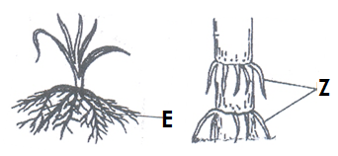

1. Name the roots marked **E** and **Z**.

i) **E**____________________________________________________________________

ii) **Z**____________________________________________________________________

1. Give two uses of roots to plants.

i) _____________________________________________________________________

ii)_____________________________________________________________________

1. **Study the diagram below and answer questions that follow.**

a) What practice is shown in the diagram above?

_______________________________________________________________________

b) Give two advantages of the above practice to a farmer.

i) _____________________________________________________________________

ii)_____________________________________________________________________

c) Identify one root tuber from the crops in the cycle above.

_______________________________________________________________________

1. a) Give the use of the following garden tools

i) Trowel ______________________________________________________________

ii) sickle ________________________________________________________________ b) Give two ways of caring for garden tools.

1. __________________________________________________________________
2. __________________________________________________________________
3. a) What are vectors?

_______________________________________________________________________

_______________________________________________________________________

b) Identify any two disease vectors.

i) ____________________________________________________________________

ii)_____________________________________________________________________

1. State any way of controlling disease vectors.

_______________________________________________________________________

1. 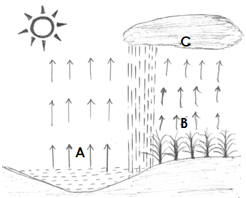**The diagram below shows a water cycle.**
2. Identify the processes marked **A, B,** and **C**.

i) **A**__________________________________

ii) **B**__________________________________

iii)**C**___________________________________

1. Give one danger of too much rainfall.

____________________________________________________________________________

1. a) Mention the component of air that is needed in each of the following process.

i) Germiantion___________________________________________________________

ii) putting out fire_________________________________________________________

1. 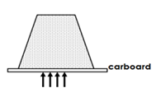Identify the properties of air shown by each of the diagrams below.

__________________________________________________________

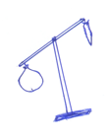

_______________________________________________

1. a) What is sanitation?

_______________________________________________________________________

b) Write down two requirements of a clean home.

i) _____________________________________________________________________

ii)_____________________________________________________________________

c) Give one way in which a P.4 can promote sanitation in a home.

_______________________________________________________________________

1. **Complete the table below correctly by filling in the missing information.**

|  |  |  |  |
| --- | --- | --- | --- |
|  | **ANIMAL** | **ITS YOUNG ONE** | **HABITAT** |
| i | Cow | ___________________ | Byre |
| ii | Lion | Cub | ____________________ |
| iii | __________________ | Puppy | Kennel |
| iv | Rabbit | Kit | ____________________ |

***“GOOD LUCK”***